Location and date:
- Skyline High School on Saturday, 2/10/2024
- Address: 1122 228th Ave SE, Sammamish, WA 98075

Meet Policies and Regulations:

The meet shall be governed by WIAA rules and regulations.

Meet Director:

Jordan Frost – Issaquah SD frostj@issaquah.wednet.edu Cell Phone: 253-951-5056

Meet Manager:

Ryan Fleisher – Issaquah/Skyline issygymnatics@yahoo.com Cell Phone: 425-443-1899

Games Committee:

Jordan Frost/Rich Klee/Jordan Halstead, one coach that is not involved and one official.

School Roster: Roster of competitors are due to Ryan Fleisher by 2/5/2024: 2 coaches, attending admin and competing gymnasts only. Pleases used the table provided on page 4.
- Please indicate how many are competing in each event if it is less than 6. (Event maximum)
- Rosters are used for Districts and State. Please note that the roster does not change for State. If an athlete is not available to compete at the State meet, the athlete is not eligible to compete at the District meet.
- Non-competing gymnasts will need to purchase a ticket to attend.
- Please note that additional coaches will need to purchase tickets. Only two coaches per team are allowed on the competition floor.

Admission Prices: Tickets will not be sold on site. Tickets are purchased on GoFan.com. THERE WILL NOT BE A CASH BOX ON SITE. Directions are on page 3 and 4.
- Cheerleaders in uniform/team sweats will be admitted free (to be seated in the stand, not floor access).
- Adults, student w/o ASB - $9 base ticket price plus online fee
- Seniors, students with ASB, K-8 - $6 base ticket price plus online fee
- Pre-school and under – no charge

Passes: WSSAAA, WIAA and District 1/2/8 passes are the only passes that will be honored. Specifically, League faculty passes, and scouting passes will not be honored.

Inquiry Forms: Will be provided. Inquiries must be completed and turned in before the end of each rotation. Inquires will follow the WIAA Inquiry Policy.

Sportsmanship/Spirit: Signs, Flags, Noisemakers, Bands
- Each school may have one official school banner.
- Noisemakers will not be allowed. Any fan unwilling to give up noisemaker(s) will be removed.
- No handheld signs including big heads.
- No balloons.
- No flash photography. Anyone taking pictures must be seated in the stands.
- No distractions of any kind.

Post Season Playoff Supervision:
Each school must have an administrator or designee present for crowd control issues with their fans. It is not the job of the tournament director or meet managers to address fan behavior during the meet.

Medical and Athletic Training: There will be a trainer on site for all sessions. Each school needs to provide their own tape, pro wrap and supplies. Please bring your training kits.

Equipment: Here is a list of the meet equipment that will be available besides the mats at each rotation:
- vault safety zone folding
- RO entry mat (rectangle)
- 8 in for each event-yes
- 20cm vault landing mats

Music: Each school will provide their own music in an MP3 format. No CDs.

Rotations: Rotations will be emailed the week of the District meet.

Entries: Each school can compete a max of 6 athletes per event.

Meet Format: Warm up four events. Compete with no one touch.

Allocations: To State from District #1/#2/#8:

- 2 teams 3 AAs 9 Individuals

Crowd Control: The floor is limited to athletes competing. Athletes that are not competing need to be in the stands.

Belongings: Skyline High School in not responsible for the safety of belongings. Athletes need to keep belongings
with them. Please have the girls limit what they bring – no blankets, pillows, extra bags, extra backpacks etc.

Photographers are not allowed on the competition floor. They need to be in the stands and not use flash photography. All photographers must have WIAA approved media credentials and they must be visible.

Time Schedule: Specific time schedule will be sent out with the draw the week of 2/5/24.

Awards: Immediately following the last session. After awards is when pictures of qualifiers are taken for the state program, so everyone who competed must be at awards.

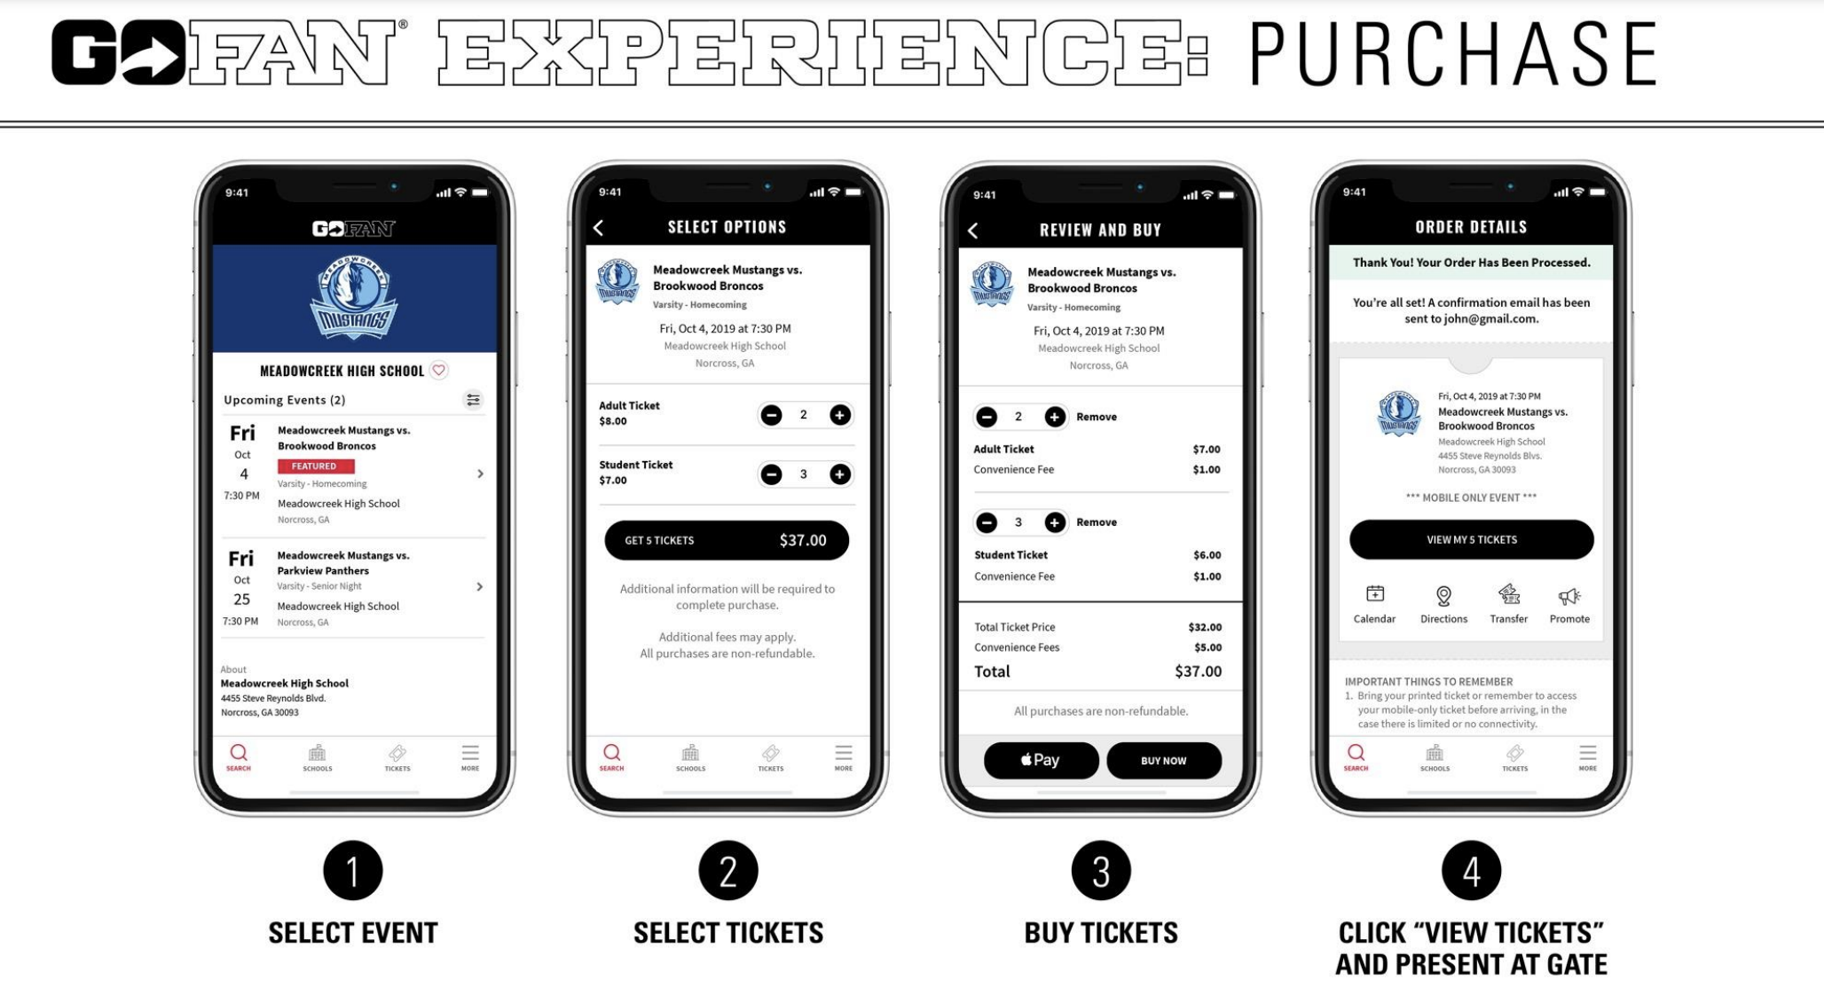

TO REDEEM:

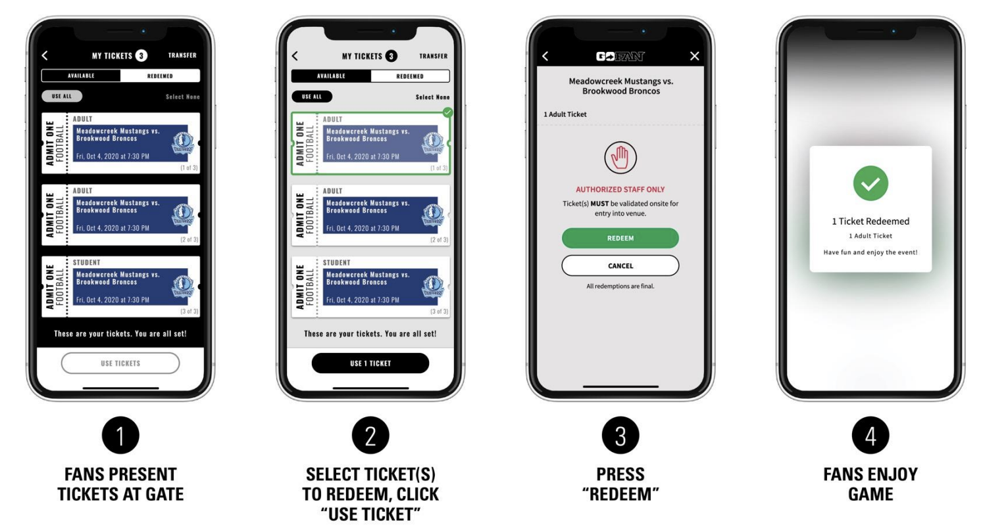

School:
Head Coach:
Assistant Coach:
Administration
Competing Athletes:

Last Name | First Name |  | Year (9,10,11,12)

