
ADVANCE INFORMATION BULLETIN
West Central District III
GIRLS FLAG FOOTBALL TOURNAMENT
JANUARY 30-31, 2026

SITE INFORMATION and PLAYING SURFACE

George Nordi Field at Mount Tahoma Stadium
4634 S 74th St
Tacoma, WA 98409

SURFACE: Field Turf. Most players wear normal cleats used on a natural grass surface. No metal cleats are allowed.

GAME and SITE MANAGER

Site Manager: Chris Fuller PHONE: 253-579-9664 (CELL)
Mt. Tahoma High School EMAIL: cfuller@tacoma.k12.wa.us

IMMEDIATE ATTENTION AND ACTION REQUIRED

Make copies and distribute this bulletin to the Principal, Athletic Director and Head Coach

TEAM ROSTER will be pulled from the Roster Center. Please update it in a post-season format no later than Thursday by noon.

E-mail Supervisory Gate List of school representatives to cfuller@tacoma.k12.wa.us , no later than noon on Thursday.

ADMISSION PRICES

Adults & Students w/out ASB cards $10.00
Students w/ ASB (SR & JR. HIGH) $5.00
Senior Citizens 62+, Military $5.00 Ticketing is exclusively done through GoFan.
Elementary - Under 12 $5.00 Please pre-purchase your online tickets at GoFan-WCD
Children 5 and under free

*Additional GoFan processing fees will apply to ticket prices
**All students must pay admission, no free entry with ASB for either school.

TICKET GATE: Will open 30 minutes prior to gametime.

DIRECTIONS and PARKING

DIRECTION FOR BUSSES:

I-5 South from Seattle:
Take exit 129, S 72nd St/S 74th St. Take the S 74th St West. Turn right at the end of the exit. Stay on S 74th St for 1.9 miles. Turn left on Verde Street, just before George Nordi Field at Mount Tahoma High School. Turn right into the bus loop just after the tennis courts. Teams will enter on the South End of the field at the Bell Tower.

I-5 North from Olympia:
Take exit 129, S 72nd St/S 74th St. Turn left at the light at the exit. Stay on S 74th St for 1.9 miles. Turn left on Verde Street, just before George Nordi Field at Mount Tahoma High School. Turn right into the bus loop just after the tennis courts. Team will enter on the South End of the field at the Bell Tower.

DIRECTIONS FOR SPECTATORS:

I-5 South from Seattle:
Take exit 129, S 72nd St/S 74th St. Take the S 74th St West. Turn right at the end of the exit. Stay on S 74th St for 1.9 miles. Turn left onto Mullen Street (at the traffic light into the parking lot).

I-5 North from Olympia:
Take exit 129, S 72nd St/S 74th St. Turn left at the light at the exit. Stay on S 74th St for 1.9 miles. Turn left onto Mullen Street (at the traffic light in to the parking lot).

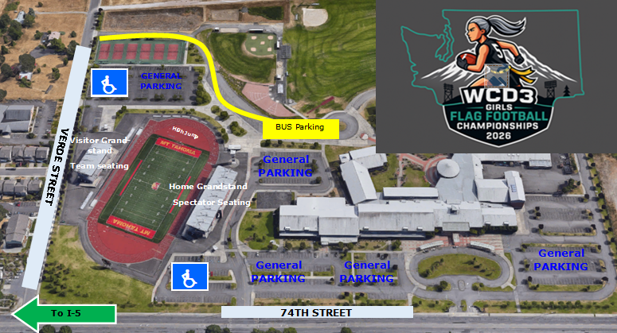

PASSES and GROUP ACCESS

SUPERVISOR PASS
Your supervision pass list must be emailed to Chris Fuller, no later than NOON on Thursday.

Accepted Passes: WCD Executive Board, SWD Executive Board, District III Lifetime, WCD Eligibility, WOA member or observer card, WSSAAA, WSCA Coaches Association.

Cheerleaders IN UNIFORM will be admitted free.

PRESS / TV / RADIO PASSES
May be obtained by contacting Site Manager, Chris Fuller and displaying an appropriate media pass.
Radio and TV broadcasts must submit an application and obtain approval through the West Central District Director.

FACILITY INFO and SPECTATOR SEATING

NO OUTSIDE FOOD OR DRINKS ALLOWED. Concessions will be provided through concession booths located at each end of the stands.

Halftime is 10 minutes. There will be NO HALF TIME field shows by Band, Drill, or Cheer.

NO signs other than the OFFICIAL SCHOOL BANNER will be allowed. Positively stated hand held signs are permitted, so long as they don’t block the view of other spectators.

Restrooms are located at each end of the stadium. Locker rooms are for team use only. There are restrooms connected to the team rooms and are only to be used by team members.

SEATING
The home side will be open for spectators, and the visitors side will be open for team seating.

Postseason tournament regulations state that a section of seating can be available for students who wish to stand for prolonged periods. (WIAA State Tournament Packet. PG. 14, Item Q)

Field 1 Team fans will sit on the North end of the home stadium. WARNING: Viewing the game from the Student Section may be obstructed due to prolonged standing.

Field 2 Team fans will sit on South end of the home stadium. WARNING: Viewing the game from the Student Section may be obstructed due to prolonged standing.

TEAM INFORMATION

TEAM ROSTERS LIMIT: 21 players and 7 Support personnel (coaches, managers, statistician) and 1 medical

The number of people on the sidelines is limited to team members in uniform, coaches, and managers, ball boy/girl, team physician or trainer (28). The only coaches permitted to be on the sidelines during a state or district playoff contest shall be limited to the coaches who have been named as flag football coaches by the school district for the regular season. All other people without sideline authorization from game manager will be escorted to grandstand.

SIDELINES & TEAM BENCH
Both team benches will be placed on the sidelines. Home team (bottom of the bracket) on the South and Visiting team (bottom of the bracket) on the North side. Bench covers WILL NOT be provided by host site. All Fans are restricted to the Main Grandstand.

Home Team will warm up on the East end of the field and Visiting teams will warm up on the West end of the field.

It is the responsibility of each team to keep all personnel inside the team box on the playing field.

NO SHELLED SEEDS, SUGAR DRINKS (IE. GATORADE) OR FOOD OF ANY KIND ALLOWED ON THE TURF. SCHOOLS VIOLATING THIS RULE WILL BE BILLED FOR CLEANUP COSTS.

GAME JERSEYS
HOME: DARK COLORED JERSEYS
VISITOR: WHITE JERSEYS

LOCKER ROOMS
Are available on both sides of the stadium but are not designated for specific team.
All equipment and personal belongings must not be stored in the locker room and should kept in the team grandstands or sideline.

PRE-GAME WARMUP and SCHEDULE
Teams will be allowed on the stadium for pre-game protocols no earlier than 30 minutes prior to the scheduled game time.

Warm-ups can be started on football field in the end zones.

Pre-game warm up will be a minimum of 20 minutes. The following time schedule will be kept, using the field scoreboard clock: Teams can warm-up all the way to 00:00 on the scoreboard. When the warm-up time expires, teams need to clear the field and organize on their sideline in front of their team bench.

CLOCK
The official game time will be kept on the field by the head official.

OFFICIALS
Four (4) WOA certified officials will be assigned to the game. Officials are selected by their association to work at this tournament and are assigned by their association. The WIAA Flag Football Manual will be the official rules for all games.

GAMES COMMITTEE
The Games Committee will include the following:
Brian Smith (KSD)
Bridgette Lopez (SHS)
John Yellam (FWSD)
Lisa Kelly (KMHS)
Brian Kaelin (SSD)
Bryan Strelesk (BSD)
Steve Taylor (CHS)

The Games Committee, composed of at least three and no more than 5 of the individuals listed above, will hear and decide on any protest and/or appeal.

MEDICAL
There will be one Certified Athletic Trainer located on the team side of the stadium.

PROTESTS
All WIAA Post Season Tournaments will follow the Protest Process outlined in Rule 29.0.0 of the WIAA Handbook. Please visit the Postseason Protest Procedures resource page for general and sport-specific guidelines.

SPECTATOR EXPECTATIONS

STUDENT CONDUCT
As games are school functions, ALL SPECTATORS are expected to exercise good judgement in their conduct and dress. UNACCEPTABLE CONDUCT IS CAUSE FOR EJECTION FROM THE PREMISES. Artificial noisemakers, such as air horns, bells, whistles, thundersticks, etc. are prohibited, as is the throwing of confetti, and/or other objects. Megaphones are to be used by the cheer staff only.

It is important that building administrators provide game supervision in the stands and promote a safe enjoyable event for everyone. Please remind students to wear shirts, to observe the stadium policy of no body or face paint, no masks, and to observe good sportsmanship. If an issue with one of your students arises we will ask you to address it.

FAN AND SPECTATORS
The tournament manager will assign each participating school a rooting section. The supervision of this section will be the responsibility of the school. Spectators are not allowed on the track or playing field at any time, and are required to stay behind the fenced areas at all times.

DUTIES OF SCHOOL SUPERVISORS
Report to the event manager at least 30 minutes prior to their team’s match.
Must wear supervisor/school identification so that it is visible and easily seen.
Sit with your school’s student body and fans while your team is competing. Being on your teams sideline/bench does not constitute proper supervision.
Be active and visible in the cheering section with your student body and fans during all contests in order to discourage problems.
Be willing to approach students and/or community representatives who display inappropriate behavior.
Notify tournament staff of potential problem individuals.
Be of assistance as requested by facility security staff or tournament management staff.
Be sure aisles and stairways are kept clear in the stands.
Keep your students and fans from entering the playing surface.
Assist in the orderly flow of traffic of fans entering and exiting the facility.
At the conclusion of your game, assist your school’s students and fans in leaving the bleachers.
Foster the traits of good sportsmanship.

