ADVANCE INFORMATION BULLETIN
West Central District III
GIRLS FLAG FOOTBALL TOURNAMENT



JANUARY 30-31, 2026

SITE INFORMATION and PLAYING SURFACE

French Field (Turf)
10020 SE 256Th St, Kent, WA 98030

GAME and SITE MANAGER

Site Manager: Brian Smith PHONE: 253-373-7251 (WK)
Director of Athletics and Activities 253-329-4106 (CELL)
Manager work location: Kent School District EMAIL: brian.smith2@kent.k12.wa.us

IMMEDIATE ATTENTION AND ACTION REQUIRED

Make copies and distribute this bulletin to the Principal, Athletic Director and Head Coach

TEAM ROSTER will be pulled from the Roster Center. Please update it in a post-season format no later than Thursday by noon.

E-mail Supervisory Gate List of school representatives to brian.smith2@kent.k12.wa.us, no later than noon on Thursday.

The home team (bottom of the bracket) is required to provide a designated score keeper to display scores for the teams and fans. The scoreboard will be provided.

ADMISSION PRICES

Adults & Students w/out ASB cards $10.00
Students w/ ASB (SR & JR. HIGH) $5.00
Senior Citizens 62+, Military $5.00 Ticketing is exclusively done through GoFan.
Elementary - Under 12 $5.00 Please pre-purchase your online tickets at GoFan-WCD
Children 5 and under free *Additional GoFan processing fees will apply to ticket prices

**All students must pay admission, no free entry with ASB for either school.

TICKET GATE: Will open 30 minutes prior to gametime.

DIRECTIONS and PARKING

Bus Unloading – Buses will need to unload in the upper parking lot of the Kent-Meridian campus, behind the
stadium and gyms. You will need to enter the campus utilizing the transportation entrance (off of 104th Ave S - 25403 SE 253rd Pl, Kent, WA 98030) and follow the road to the back of the campus bus parking.

The visiting (west) side of the stadium is for officials, staff only, and team personnel. The parking lot on the west side is strictly for staff and officials parking. Rostered team members and team personnel will enter through the pass gate on the northeast side of French Field.

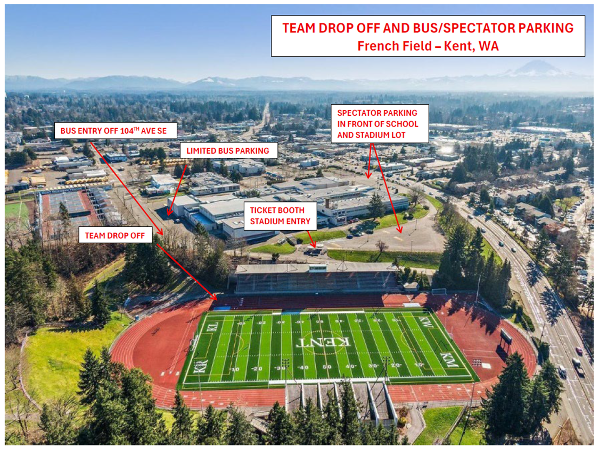

PASSES and GROUP ACCESS

SUPERVISOR PASS
Your supervision pass list (included in the email that provided this syllabus) must be emailed to Brian Smith, no later than NOON on Thursday.

Accepted Passes: WCD Executive Board, SWD Executive Board, District III Lifetime, WCD Eligibility, WOA member or observer card, WSSAAA, WSCA Coaches Association.
*No other league or seasonal passes will be accepted.

STADIUM RE-ENTRY
No PASS-OUT (re-entry) once admitted. This includes halftime. We will allow re-entry for emergencies at the discretion of stadium staff.

GROUPS
Cheerleaders IN UNIFORM will be admitted free.
Home schools please let me know if there will be any halftime activities.

PRESS / TV / RADIO PASSES
May be obtained by contacting Game Manager and displaying an appropriate media pass.
Radio and TV broadcasts must submit an application and obtain approval through the West Central District Director.

FACILITY INFO and SPECTATOR SEATING

Concessions WILL NOT be provided.

Halftime is 10 minutes.

NO signs other than the OFFICIAL SCHOOL BANNER or DISTRICT BANNER will be allowed.

Spectator Restrooms are at the North end of the home side Stadium.

Locker rooms are for team use only.

SEATING
Postseason tournament regulations state that a section of seating can be available for students who wish to stand for prolonged periods. (WIAA State Tournament Packet. PG. 14, Item Q)

Field 1 Team fans will sit on the North end of the home stadium. WARNING: Viewing the game from the Student Section may be obstructed due to prolonged standing.

Field 2 Team fans will sit on South end of the home stadium. WARNING: Viewing the game from the Student Section may be obstructed due to prolonged standing.

TEAM INFORMATION

TEAM ROSTERS
LIMIT: 21 players and 7 Support personnel (coaches, managers, statistician) and 1 medical

The number of people on the sidelines is limited to team members in uniform, coaches, and managers, ball boy/girl, team physician or trainer (28). The only coaches permitted to be on the sidelines during a state or district playoff contest shall be limited to the coaches who have been named as flag football coaches by the school district for the regular season. All other people without sideline authorization from game manager will be escorted to grandstand.

SIDELINES & TEAM BENCH
Both team benches will be placed on the sidelines. Home team (bottom of the bracket) on the East and Visiting team (bottom of the bracket) on the West side. Bench covers WILL NOT be provided by host site. All Fans are restricted to the Main Grandstand.

Home Team will warm up on the North end of the field and Visiting teams will warm up on the South end of the field.

It is the responsibility of each team to keep all personnel inside the team box on the playing field.

NO SHELLED SEEDS, SUGAR DRINKS (IE. GATORADE) OR FOOD OF ANY KIND ALLOWED ON THE TURF. SCHOOLS VIOLATING THIS RULE WILL BE BILLED FOR CLEANUP COSTS.

GAME JERSEYS
HOME: DARK COLORED JERSEYS
VISITOR: WHITE (Light) JERSEYS

LOCKER ROOMS
HOME: North locker room.
VISITOR: South locker room.
All equipment and personal belongings must not be stored in the locker room and should kept in the team grandstands or sideline.

PRE-GAME WARMUP and SCHEDULE
Teams will be allowed on the stadium for pre-game protocols no earlier than 30 minutes prior to the scheduled game time.

Warm-ups can be started on the baseball field outfield located on the KM campus. The home teams will use the northern half and the visitors the southern half of the outfield. Teams can utilize the warm-up field upon arrival.

Pre-Game locker rooms will be available at the bus drop off area and warm-up field.

Pre-game warm up on the competition field will be a minimum of 20 minutes. The following time schedule will be kept, using the field scoreboard clock: Teams can warm-up all the way to 00:00 on the scoreboard. When the warm-up time expires, teams need to clear the field and organize on their sideline in front of their team bench. Warming up in the lower stadium will not be permitted while teams are playing.

Clock
The official game time will be kept on the field by the head official. The field score will be displayed.

Officials
Four (4) WOA certified officials will be assigned to the game. Officials are selected by their association to work at this tournament and are assigned by their association. The WIAA Flag Football Manual will be the official rules for all games.

GAMES COMMITTEE
The Games Committee will include the following:
Tournament/Event Manager – Brian Smith (KSD)
Bridgette Lopez (SHS)
John Yellam (FWSD)
James Neil (TPSD)
Lisa Kelly (KMHS)
Brian Kaelin (SSD)
Bryan Streleski (BSD)
Jim Meyerhoff (PSD)

The Games Committee, composed of at least three and no more than 5 of the individuals listed above, will hear and decide on any protest and/or appeal.

MEDICAL
There will be one Certified Athletic Trainer located on the team side of the stadium.

PROTESTS
All WIAA Post Season Tournaments will follow the Protest Process outlined in Rule 29.0.0 of the WIAA Handbook. Please visit the Postseason Protest Procedures resource page for general and sport-specific guidelines.

SPECTATOR EXPECTATIONS

STUDENT CONDUCT
As games are school functions, ALL SPECTATORS are expected to exercise good judgement in their conduct and dress. UNACCEPTABLE CONDUCT IS CAUSE FOR EJECTION FROM THE PREMISES. Artificial noisemakers, such as air horns, bells, whistles, thundersticks, etc. are prohibited, as is the throwing of confetti, and/or other objects. Megaphones are to be used by the cheer staff only.

It is important that building administrators provide game supervision in the stands and promote a safe enjoyable event for everyone. Please remind students to wear shirts, to observe the stadium policy of no body or face paint, no masks, and to observe good sportsmanship. If an issue with one of your students arises we will ask you to address it.

Fan and Spectators
The tournament manager will assign each participating school a rooting section. The supervision of this section will be the responsibility of the school. Spectators are not allowed on the track or playing field at any time, and are required to stay behind the fenced areas at all times.

Duties of School Supervisors
Report to the event manager at least 30 minutes prior to their team’s match.
Must wear supervisor/school identification so that it is visible and easily seen.
Sit with your school’s student body and fans while your team is competing. Being on your teams sideline/bench does not constitute proper supervision.
Be active and visible in the cheering section with your student body and fans during all contests in order to discourage problems.
Be willing to approach students and/or community representatives who display inappropriate behavior.
Notify tournament staff of potential problem individuals.
Be of assistance as requested by facility security staff or tournament management staff.
Be sure aisles and stairways are kept clear in the stands.
Keep your students and fans from entering the playing surface.
Assist in the orderly flow of traffic of fans entering and exiting the facility.
At the conclusion of your game, assist your school’s students and fans in leaving the bleachers.
Foster the traits of good sportsmanship.

